Mobile game proposal
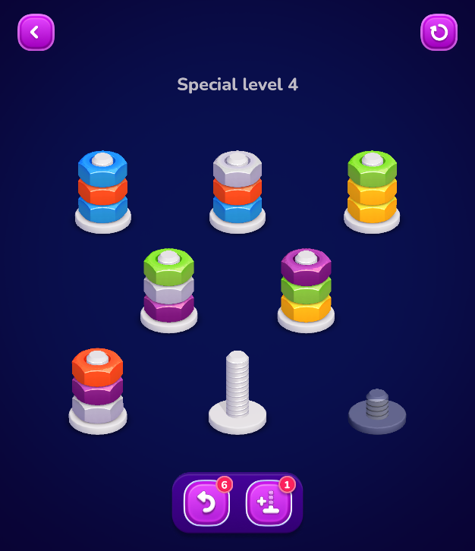
My game plan is to make a game similar to the games where you sort piles of coloured items from random stacks into a stack of only its own colour, only being able to put colours onto of their own colours. The difference with my game is that there will be plushies of different animals (colour themed and textured differently so it is easy to tell which animals go on top of each other for both colourblind and non-colourblind people) so once each plushie is completed an animal plushie is completed instead of just a coloured column or glass of coloured liquid. My game will also require the plushies to be assembles in the correct order.

The core gameplay loop is tapping to move the pushes from one column to another to create a completed plushie while having few columns to move them to while re-arranging the plushie components.

Intended audience is a people of any age that play casual puzzle games on their phones for a small portion of time a day. This game is targeted towards android phones being played in portrait mode, the game will lock the screens rotation being unable to flip the screen to landscape at all.

The touch screen control system used will be simply just tapping the screen and the mobile specific feature will be haptics one a column in completed and when a level is completed

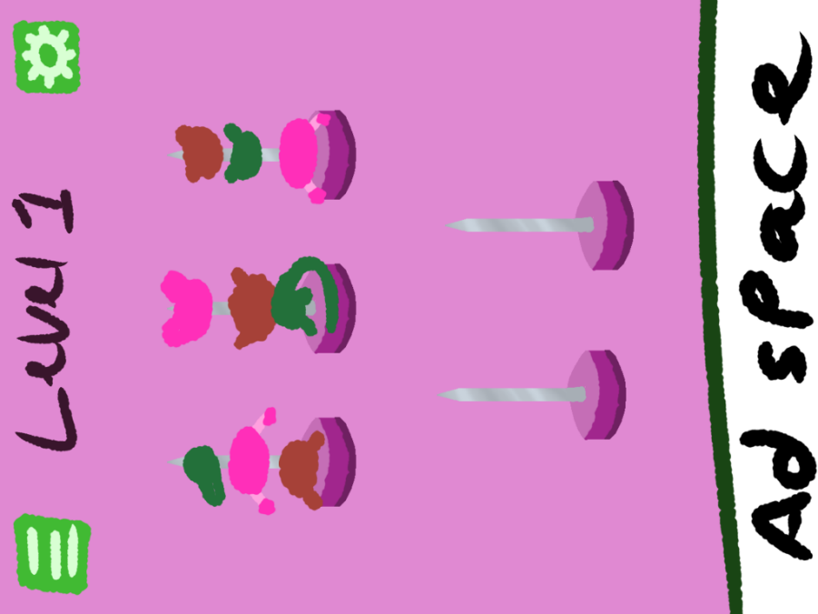
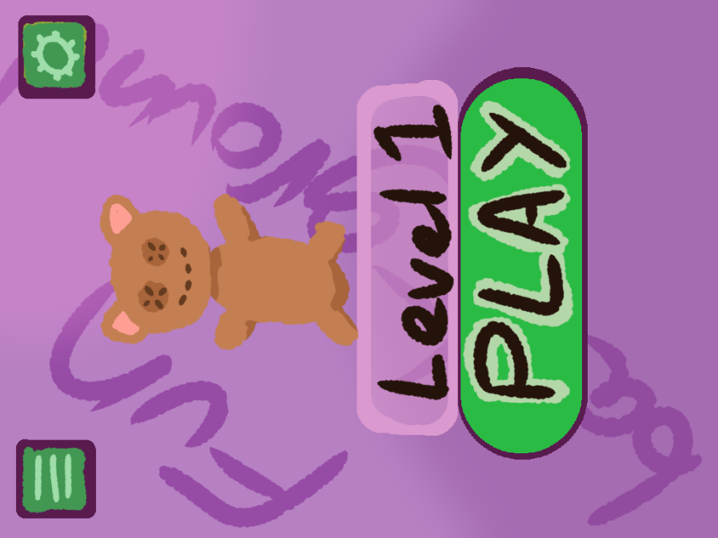
Wire frame pictures:

